**Protestors arrested in equal numbers at private and public U.S. universities when adjusted for crowd size**

By: Mia Hollie, Diana Escamilla, Julian Tiburcio, Laura Turbay

Nearly 2,000 arrests and detainments of protesters at pro-Palestinian demonstrations have been made on university campuses across the US. Although public universities had 43% more number of arrests, when normalized for crowd size, the average number of arrests is nearly identical for public and private universities, showed an [analysis](https://github.com/miahollie/encampment-proj) by New York City News Service.

Arrests for both public and private universities average at about 25 when accounting for crowd size, which was based on eyewitness accounts from various news sources. The mass arrests come at a time when Israel's heavy military response in Gaza has sowed a deep divide between students and university leaders over college investments linked to Israel and a public call for a ceasefire.

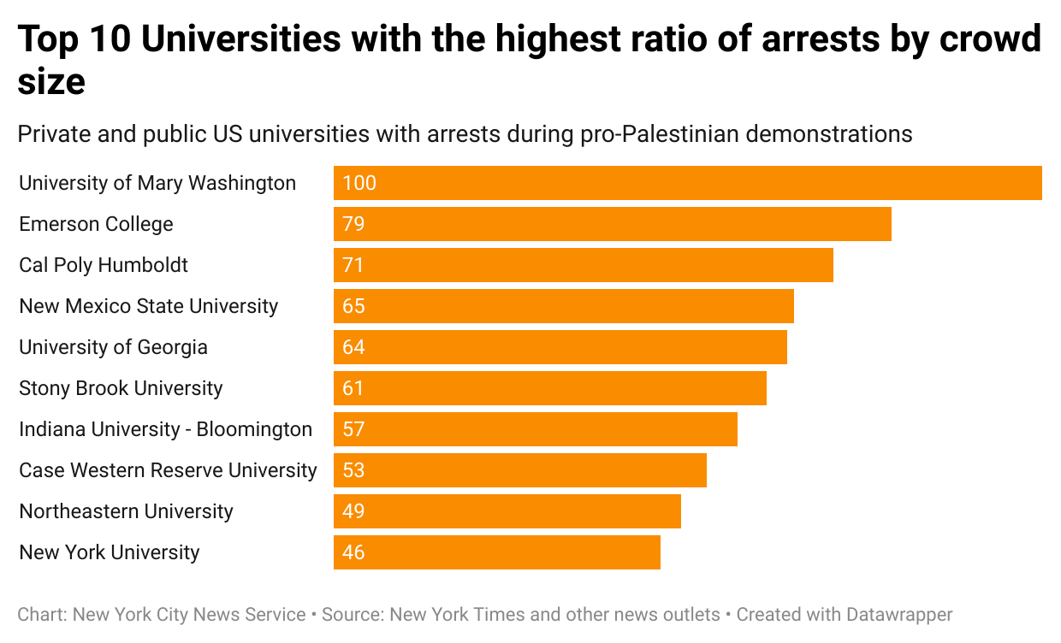

Encampments began at Columbia University on April 18, with a demonstration [of 550 of](https://www.nytimes.com/2024/04/22/us/columbia-university-protests.html) peaceful protestors and faculty-led teach-ins. But police force was swiftly deployed after protesters occupied Hamilton Hall (renamed Hind's hall by protesters), and 217 students and protesters were arrested, according to [New York Times](https://www.nytimes.com/interactive/2024/us/pro-palestinian-college-protests-encampments.html) data as of May 16. Columbia is the only private university in the top five universities with the highest number of arrests.

By then, protests had already spread like wildfire. As many as [67 private and public](https://www.nytimes.com/interactive/2024/us/pro-palestinian-college-protests-encampments.html) college campuses had seen protestors detained or arrested in the weeks leading up to May graduation. In public universities police force was used twice as much, with 46 arrests or detainments, than in private universities which had 21. One reason for this may be that more protests have taken place at public universities.

**Data**

Available on [GitHub](https://github.com/miahollie/encampment-proj) by Mia Hollie, Julian Tiburcio, Diana Escamilla and Laura Turbay

[Methodology](https://docs.google.com/document/d/1FQdK5tnlHS7htzaxqKZIvuO0PoICL3SeQZ6Uhz39UC4/edit)